EX.NO: 8
Query with Sub Query & Correlated Query
AIM
To perform SQL queries using Sub Query and Correlated Query on the MobileSales table.

PROCEDURE
- Select the required database using the USE command.
- Display the records from the MobileSales table.
- Execute a Sub Query to retrieve records based on the result of another query.
- Execute a Correlated Query to retrieve records by comparing values within the same table.
- Display the results of each query.
- Observe the output and verify that the Sub Query and Correlated Query return the expected records.

COMMANDS
1. Select the Database
USE MobileDB;

2. Display All Records
SELECT * FROM MobileSales;
3. Sub Query
SELECT *
FROM MobileSales
WHERE Price >
(
SELECT AVG(Price)
FROM MobileSales
);
4. Sub Query
SELECT *
FROM MobileSales
WHERE CustomerReview =
(
SELECT MAX(CustomerReview)
FROM MobileSales
);

5. Correlated Query
SELECT *
FROM MobileSales M1
WHERE Price >
(
SELECT AVG(Price)
FROM MobileSales M2
WHERE M1.ModelYear = M2.ModelYear
);
6. Correlated Query
SELECT *
FROM MobileSales M1
WHERE Price =
(
SELECT MAX(Price)
FROM MobileSales M2
WHERE M1.ModelYear = M2.ModelYear
);

OUTPUTS
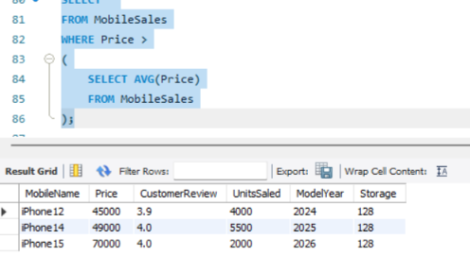

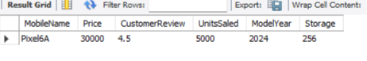

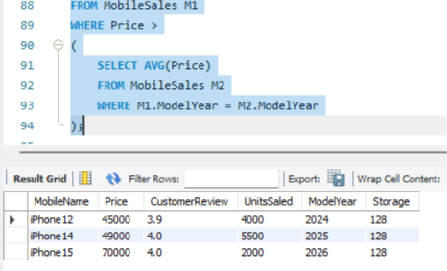

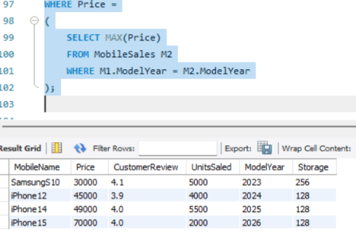

RESULT
Thus, the Sub Query and Correlated Query were successfully executed on the MobileSales table to retrieve records based on nested queries and correlated conditions.

